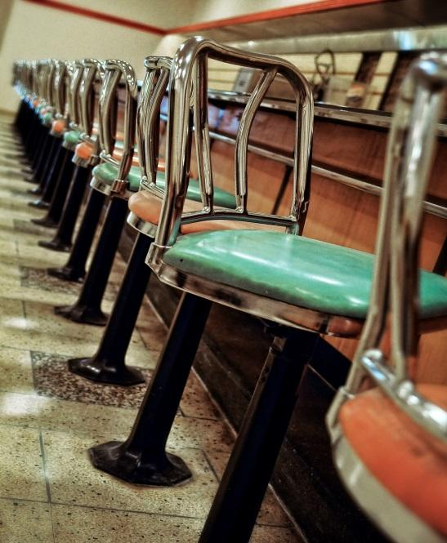

The International Civil Rights Center and Museum is a place that all visitors to Greensboro simply must visit. The authentic setting of one of the key events in the American Civil Rights Movement is preserved there along with a stunning interactive presentation. Students of NBNO-host school, NCA&T, were at the heart of the Woolworth’s sit-in protest. Taking the tour is enlightening, uplifting, and humbling as history comes alive before you. It is a personal and educational experience that you will treasure!

All NBNO 2019 athletes with a competitor bib number plus coaches and fans with a wristband will receive a $2 discount on the admission price. You must have your competitor bib and/or your wristband with you to receive the discount. Please make advanced reservations for best results. Groups of 10 or more are required to reserve their tour in advance. Go to https://www.sitinmovement.org/338-2/ or call 800-748-7116.

